
Unit 2 A restaurant of the future
Vocabulary Worksheet 2.2A
(with answers)

Look at the menu. Fill in the blanks with the correct letters.
A. apple pieB. Buffalo wingsC. Caesar salad
D. chocolate cakeE. grilled king prawnsF. seafood platter
G. sirloin steakH. strawberry cheesecake

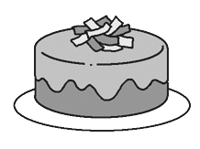
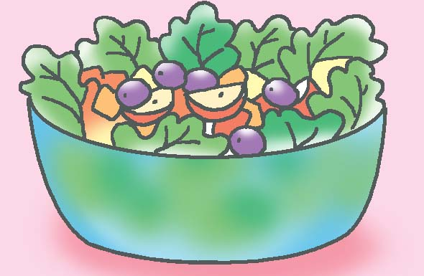
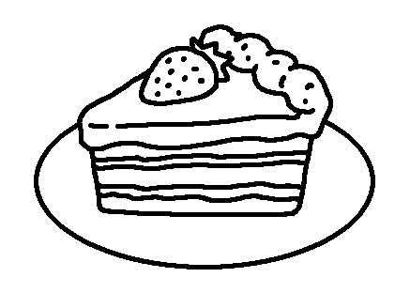
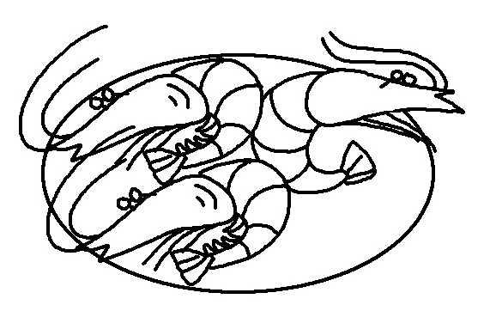
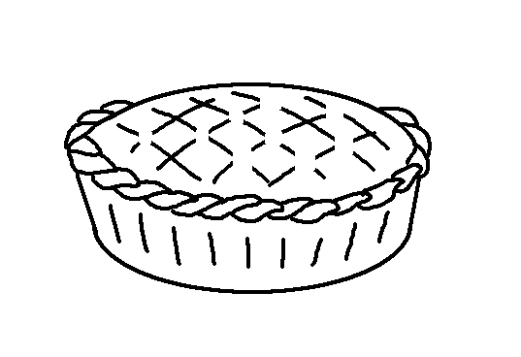
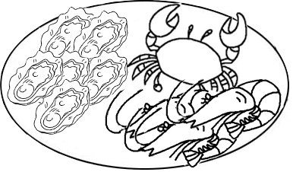
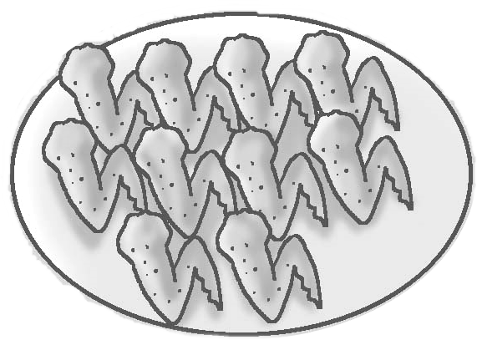
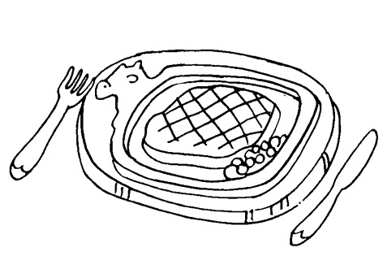
Starters
Desserts
MENU

Main Courses
◆
❖
⬥






