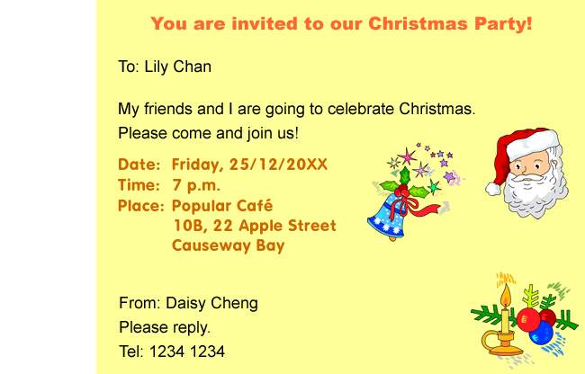

Read the invitation card and answer the questions.

1. What is the invitation about?
 A. a picnic
 B. a birthday party
 C. a football match
 D. a Christmas party

2. Who writes the invitation card?
 A. Lily
 B. Santa Claus
 C. Daisy
 D. Apple

3. Where does the party take place?
 A. at home
 B. at a café
 C. at a school
 D. at a fast food shop

4. When is the party?
 A. on a Thursday
 B. on a Friday
 C. at seven o’clock in the morning
 D. at six o’clock in the evening

