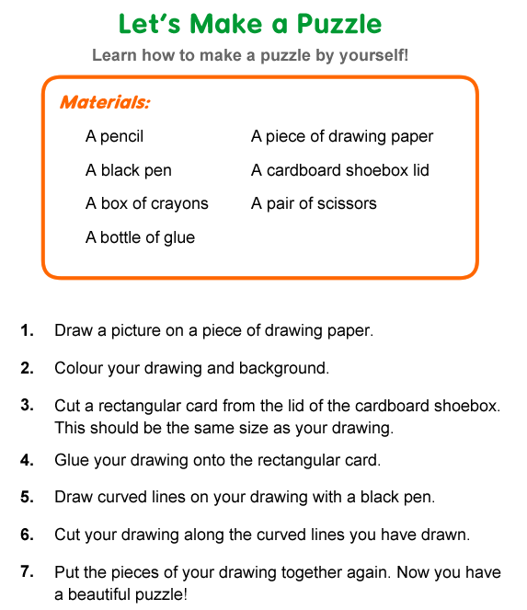

Read the instructions and answer the questions.

1. What are the instructions about?
 A. making a kite
 B. baking a cake
 C. writing a story
 D. making a puzzle

2. What materials do we NOT need?
 A. a bottle of glue
 B. a stapler
 C. a pair of scissors
 D. some crayons

3. What should we use in step 2?
 A. a bottle of glue
 B. a cardboard shoebox lid
 C. a pair of scissors
 D. a box of crayons

4. Where can you find these instructions?
 A. in a storybook
 B. in a cookbook
 C. in a book about crafts
 D. in a dictionary

