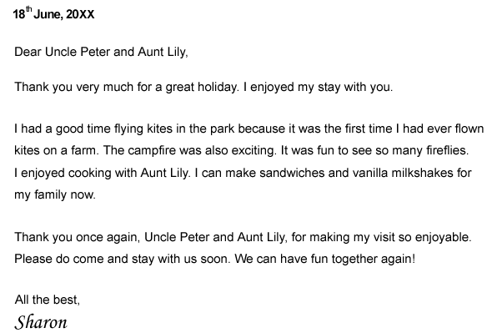

Read the letter and answer the questions.

1. Who wrote the letter?
 A. Sharon
 B. Uncle Peter
 C. Aunt Lily
 D. Uncle Peter and Aunt Lily

2. When did the sender write the letter?
 A. 8th June, 20XX
 B. 18th June, 20XX
 C. 28th June, 20XX
 D. 18th July, 20XX

3. What should we put in the box?
 A. With love,
 B. Yours sincerely,
 C. End of letter.
 D. Cousin,

4. The sender wrote the letter to __________________.
 A. make a compliant
 B. apply for a job
 C. place an order
 D. thank somebody

