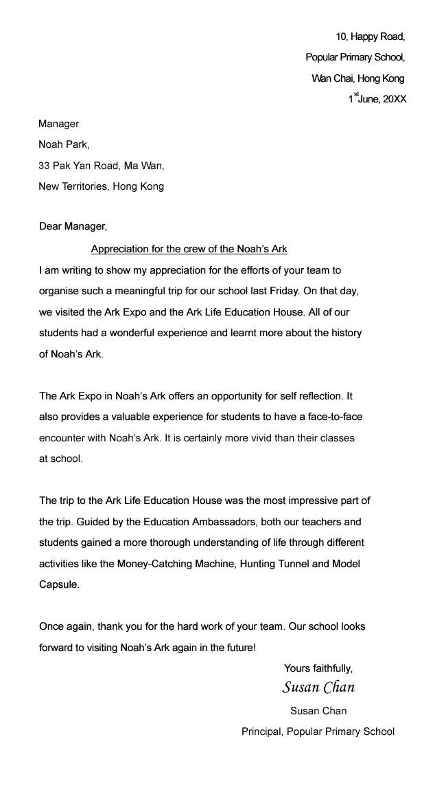

Read the letter and answer the questions.

1. Who received the letter?
 A. Noah
 B. Susan Chan
 C. the manager of Noah’s Ark
 D. the principal of Popular Primary School

2. Where is Popular Primary School?
 A. on Hong Kong Island
 B. in Kowloon
 C. in the New Territories
 D. on Lantau Island

3. What did the writer talk about in paragraph 2?
 A. the date of the event
 B. the Ark Expo
 C. the Ark Life Education House
 D. the Education Ambassadors

4. What was the writer’s tone in the letter?
 A. shocked
 B. angry
 C. sad
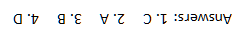
 D. satisfied

