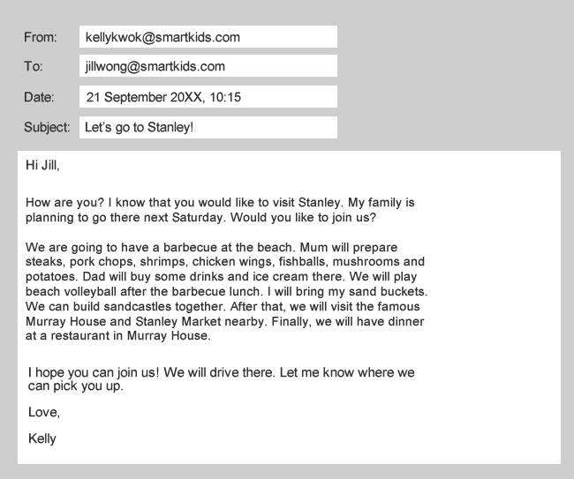

Read the email and answer the questions.

1. Who wrote the email?
 A. Kelly
 B. Jill
 C. Kelly’s mother
 D. Kelly’s father

2. What will the sender’s family NOT do during their trip?
 A. build sandcastles
 B. visit Murray House and Stanley Market
 C. play beach volleyball
 D. have a barbecue dinner

3. What is the email about?
 A. a barbecue
 B. a trip to Stanley
 C. playing beach volleyball
 D. Murray House and Stanley Market

4. The recipient got the email on __________________.
 A. 20th September, 20XX
 B. 21st September, 20XX
 C. 23rd September, 20XX
 D. 21st October, 20XX

