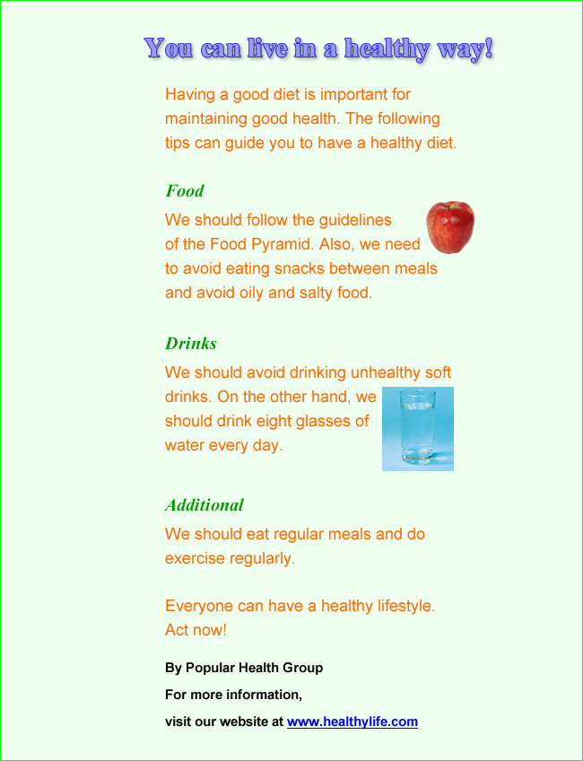

Read the pamphlet and answer the questions.

1. What is the pamphlet about?
 A. the Food Pyramid
 B. healthy eating habits
 C. Popular Health Group
 D. soft drinks

2. How can you find out more about the topic?
 A. by visiting a website
 B. by reading a newspaper
 C. by making a phone call
 D. by sending an email

3. How many subheadings are there in the pamphlet?
 A. 1
 B. 2
 C. 3
 D. 4

4. Who published the pamphlet?
 A. Popular Health Society
 B. Healthy Life
 C. Popular Health Group
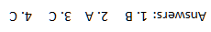
 D. the Hong Kong government

