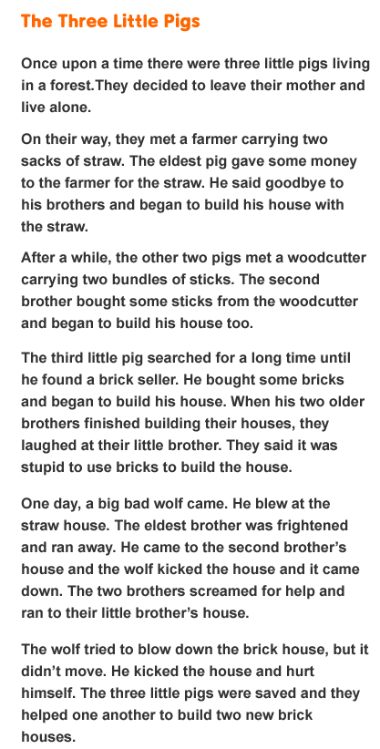

Read the story and answer the questions.

1. Where did the story take place?
 A. on a farm
 B. in a forest
 C. at a beach
 D. on a hill

2. Who are the main characters?
 A. the wolf and the three little pigs’ mother
 B. the farmer and the brick seller
 C. the three little pigs
 D. the woodcutter and the farmer

3. What problem did the main characters face?
 A. A wolf came and blew their houses down.
 B. They argued with one another.
 C. They could not build their own houses.
 D. They wanted to leave their mother and live alone.

4. What do you learn from the story?
 A. We should live with our mother.
 B. We should build houses with bricks.
 C. We should work hard and be wise.
 D. We should run away when we see a wolf.

