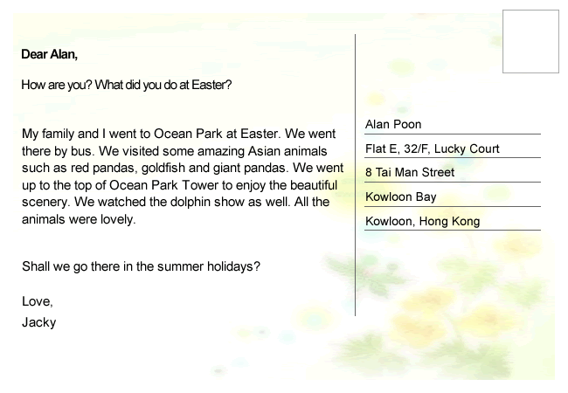

Read the postcard and answer the questions.

1. Who writes the postcard?
 A. Alan
 B. Jacky
 C. Lucky
 D. Judy

2. Where does the receiver of the postcard live?
 A. in the New Territories
 B. on Hong Kong Island
 C. on Lantau Island
 D. in Kowloon

3. What is the postcard about?
 A. Ocean Park
 B. dolphins
 C. Kowloon
 D. summer holidays

4. Read lines 3–4: ‘We went there by bus.’ Who does ‘we’ refer to?
 A. Jacky and Alan
 B. Jacky and his family
 C. Alan and his family
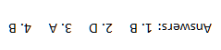
 D. Jacky’s family and Alan’s family

