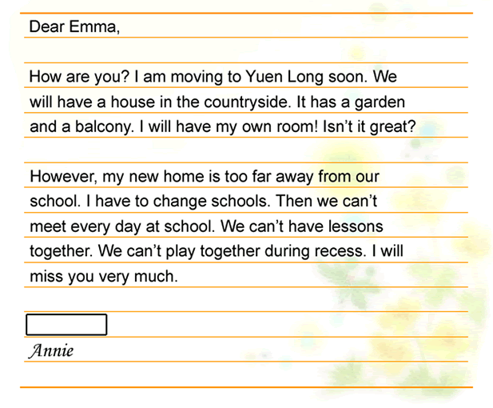

Read the letter and answer the questions.

1. Who receives the letter?
 A. Tina
 B. Emma
 C. Daisy
 D. Annie

2. Annie is going to move to __________________.
 A. Hong Kong Island
 B. Kowloon
 C. the New Territories
 D. Lantau Island

3. Emma is Annie’s __________________.
 A. sister
 B. e-pal
 C. classmate
 D. teacher

4. What should be put in the box?
 A. Best wishes,
 B. Dear Annie,
 C. The end.
 D. Yours faithfully,

