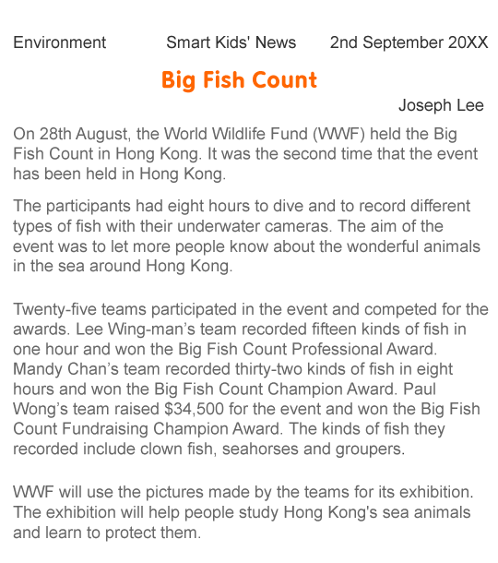

Read the newspaper article and answer the questions.

1. Who wrote the newspaper article?
 A. Mandy Chan
 B. World Wildlife Fund
 C. Joseph Lee
 D. Big Fish Count

2. When can readers read the newspaper article?
 A. in September
 B. in October
 C. in November
 D. in December

3. In which section of the newspaper can you find the newspaper article?
 A. Local News
 B. Environment
 C. Weather
 D. Business and Finance

4. What information can you find in the introduction?
 A. details about the event
 B. the future plan of the World Wildlife Fund
 C. the number of participants
 D. the date of the event

