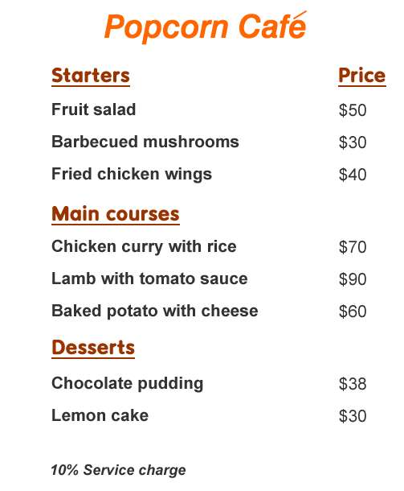

Read the menu and answer the questions.

1. Where can you find this menu?
 A. at a fast food shop
 B. at a café
 C. at a canteen
 D. at a restaurant

2. How many categories of food are there on the menu?
 A. 1
 B. 2
 C. 3
 D. 4

3. James wants to have meat for his starter. What should he order?
 A. Fruit salad
 B. Barbecued mushrooms
 C. Fried chicken wings
 D. Chicken curry with rice

4. Mr Chan ordered a lamb with tomato sauce and a lemon cake.
How much should he pay?
 A. $30
 B. $90
 C. $120
 D. $132

