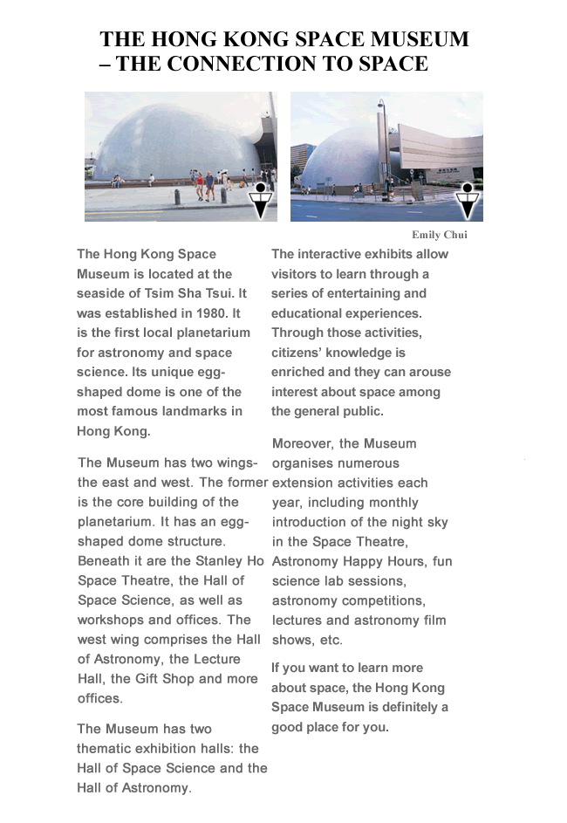

Read the magazine article and answer the questions.

1. Who wrote the magazine article?
 A. Stanley Ho
 B. Emily Chui
 C. Space Theatre
 D. Hong Kong Space Museum

2. What information can you NOT find in the article?
 A. the location of the museum
 B. the opening hours of the museum
 C. the activities held in the museum
 D. the history of the museum

3. In what kind of magazine can you find this article?
 A. a science magazine
 B. a sports magazine
 C. a health magazine
 D. a music magazine

4. The writer thinks that the Space Museum is a good place to learn more
about __________________.
 A. history
 B. space
 C. plants
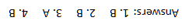
 D. animals

