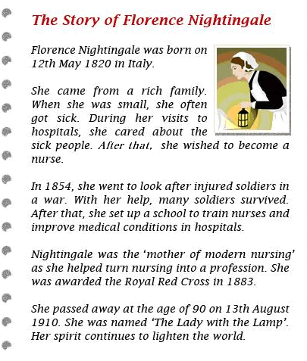

Read the biography and answer the questions.

1. What is the biography about?
 A. Italy
 B. nurses
 C. the Red Cross
 D. Florence Nightingale

2. Nightingale is __________________.
 A. a doctor
 B. a nurse
 C. a teacher
 D. a farmer

3. In which paragraphs can you find Nightingale’s personal background?
 A. paragraphs 1 and 2
 B. paragraphs 2 and 3
 C. paragraphs 3 and 4
 D. paragraphs 4 and 5

4. Which of the following is TRUE about Nightingale?
 A. She came from a poor family.
 B. She was named ‘The Lady with the Lamp’.
 C. She set up a school to train doctors.
 D. She passed away at the age of 92.

